Devesh Guntupalli

|

FINAL EXAM

G.DEVESH BABU

Contents

PART A 2

1) 2

2) 2

3) 3

4) 4

5) 5

PART B 6

PART C 7

USE CASE: 7

SEQUENCE 9

ROOM AVAILABILITY 9

BOOK A ROOM 9

REPORTS: 10

CHECK IN AND OUT 10

CLASS DIAGRAM 11

ER DIAGRM 12

# PART A

1)There are different kinds of models like Analysis, design, structural and behavioral models. The most common ways to differentiate analysis from design is that, analysis is mostly about “what” and design is “how”. The analysis step usually comes before the design, If we are sure of what to be done we can prepare ourselves for how. But interestingly in what vs how concept of analysis and design, then every concept that is an analysis concept is also a design concept and vice versa.

Analysis in simple way can be defined as modeling the customer’s business policy and business process. Design can be defined as dealing with computing technology. In analysis model we understand the problem you are trying to solve, like what environments we deploy, who are our customers and in what behaviors should your solution act. Designing is figuring out how to organize the solution once we went through the analysis we now understand the problem. Analysis would be in the requirement, use case and activity comes in that space. Where design contains class diagram, sequence diagram and state machine diagram.

Finally, analysis is nothing but analyzing user business requirements whereas design is nothing but documenting the business requirements in a format understandable by the programmers.

**REFERENCES**

1. <http://www.omg.org/news/meetings/workshops/presentations/eai_2001/tutorial_monday/tockey_tutorial/2-Analysis_vs_Design.pdfhttp://www.omg.org/news/meetings/workshops/presentations/eai_2001/tutorial_monday/tockey_tutorial/2-Analysis_vs_Design.pdf>
2. <http://www.jot.fm/issues/issue_2009_01/column7.pdf>
3. <https://www.researchgate.net/post/What_is_difference_between_analysis_and_design_of_software>

2) Service Oriented Architecture (SOA) is an approach used to create an architecture based upon of services, services such as web, carry out some small function, such as producing data, validating a customer, or providing simple analytical services. In addition to building and exposing services, SOA has the ability to leverage the services over and over again with applications. If a SOA is to be effective, we need a clear understanding of the term service. A service is a function that is well-defined, self-contained, and does not depend on the context or state of other services. SOA provides a strategic capability for integrating business processes, data and organizational knowledge. Because interfaces are platform independent, a client from any device using any operating system in any language can use the service. There are many benefits of SOA, including improved information flow, location transparency, internal software organization and better data transition. The most commonly discussed disadvantage of SOA is for application with GUI functionality. These types of application become more complex when using SOA.

SOA is not a web services, although it is built on similar principles, which indicates a collection of technologies, such as SOAP and XML. Web services can be thought of as a consumer provider relationship on the web while SOA is about designing your architecture to best work in a web service environment.

**References**

* [**http://www.webopedia.com/TERM/S/Service_Oriented_Architecture.html**](http://www.webopedia.com/TERM/S/Service_Oriented_Architecture.html)
* [**http://searchsoa.techtarget.com/definition/service-oriented-architecture**](http://searchsoa.techtarget.com/definition/service-oriented-architecture)
* [**http://www.service-architecture.com/articles/web-services/service-oriented_architecture_soa_definition.html**](http://www.service-architecture.com/articles/web-services/service-oriented_architecture_soa_definition.html)

3)This is very interesting question to answers. As we all know that they are four phase in Usability in the Product Development Life Cycle model which are:

·         Phase 1 - Concept Exploration

·         Phase 2 - Demonstration and Validation

·         Phase 3 - Detailed Design and Construction

·         Phase 4 - Production and Operation

In general scenario, any development is started from the requirement gathering, designed and tested before the final phase which is implementation. From the above phases, phase 3 (Detailed Design and Construction) in which it is determined that software is ready to go into production or by this phase we can know that further software development or testing is required or not. Once the testing in this phase 3 is done without any major bugs or prioritized bugs hence it is clear that the software is ready to production.

It is also clear that there will be no changes further to the final software if they are any changes occurred at this phase to the project then it could increase the budget and time of the product. Once again the product has to come from phase 1 to testing.

Every project has the priority and severity report and once this report shows that they are no high level bugs which are creating serious issues in project flow then project manager is ready to take the project to implementation.

Priority: is the importance of the bug which supposed to fix and in regards to the business.

Severity: Impact of the bug towards the business.

Below defines the levels of priority and severity, by this report it indicates that enough testing has been done and software is ready to go into production when the remaining bugs are at low level (P4 and S4).

REFRENCE:

* <http://tech.finn.no/2012/05/21/when-do-you-know-how-much-testing-is-enough/>

https://ssl.gstatic.com/ui/v1/icons/mail/images/cleardot.gif

4) Unreasonable deadlines are often the consequences of trying to complete the project to complete the project to accomplish some business goals rather than being based on realistic assessment of how long the project will actually take to complete.

* In many surveys on project management, many project managers and team leaders complain that they work on unrealistic schedules
* The same project managers and teams are being blamed for not meeting those dates
* Sponsors, bosses and organizations do not seem to be learning anything from this and
* The same pattern goes on again and again, unresolved

There are instances when a project that would normally be completed in 30 days to be completed in 4-12 days. Manager might be having orders from superiors but still is atrocious.

We as project managers have to develop correct and reasonable time limits for the project , and use these to convince the shareholders and bosses that the timeline set by the bosses cannot be achieved. But ours can be achievable. For example, CD selection case, the project sponsor wants the internet order system to be operational in time to sell CDs for holliday shopping and the season starts in a month cannot be achieved. There are few specific strategies for handling this,

1. Tell manager in the time wrap we could do certain of it, and improve on the other aspects in the next time frames.
2. It sounds like you’ve raised the issue on a project-specific basis, but have you talked with your manager from more of a big-picture perspective? For instance, you could say something like, “I’ve noticed that we sometimes have different ideas about what are realistic timeframes for many projects. I want to be able to do the job well and deliver a good product, but sometimes we’re given deadlines that aren’t possible to meet, not if the product is going to be any good. I believe in pushing myself and I think you know I work hard.

**REFRENCES**

* [**http://www.askamanager.org/2012/05/dealing-with-unreasonable-deadlines.html**](http://www.askamanager.org/2012/05/dealing-with-unreasonable-deadlines.html)
* [**https://books.google.com/books?id=rbLrBgAAQBAJ&pg=PA81&lpg=PA81&dq=4.%09Why+do+many+projects+end+up+having+unreasonable+deadlines?+How+should+a+project+manager+manage+unreasonable+demands?&source=bl&ots=YI3KvZNrfi&sig=pF84_dTI3iVtGIju7gBhxhpXxEc&hl=en&sa=X&ved=0ahUKEwi9rf6g797JAhWJJx4KHX9UAO4Q6AEIMDAD#v=onepage&q=4.%09Why%20do%20many%20projects%20end%20up%20having%20unreasonable%20deadlines%3F%20How%20should%20a%20project%20manager%20manage%20unreasonable%20demands%3F&f=false**](https://books.google.com/books?id=rbLrBgAAQBAJ&pg=PA81&lpg=PA81&dq=4.%09Why+do+many+projects+end+up+having+unreasonable+deadlines?+How+should+a+project+manager+manage+unreasonable+demands?&source=bl&ots=YI3KvZNrfi&sig=pF84_dTI3iVtGIju7gBhxhpXxEc&hl=en&sa=X&ved=0ahUKEwi9rf6g797JAhWJJx4KHX9UAO4Q6AEIMDAD#v=onepage&q=4.%09Why%20do%20many%20projects%20end%20up%20having%20unreasonable%20deadlines%3F%20How%20should%20a%20project%20manager%20manage%20unreasonable%20demands%3F&f=false)
* [**http://www.projecttimes.com/managing-and-surviving-imposed-and-unrealistic-time-estimates.html**](http://www.projecttimes.com/managing-and-surviving-imposed-and-unrealistic-time-estimates.html)

5) The complexity of the system is defined by its functionalities. The most of the system functionalities are driven by the functional requirements. But many of us miss that non-functional requirements are as important as their counterpart. Non- functional requirements define the overall qualities or attributes of the system. Non-functional requirements place restrictions on the product being developed, the development process, and specifically external constraints that the product must meet. These non-functional requirements act as a selection criterion for choosing among myriads of decision. Surprisingly nonfunctional requirements have not received not enough importance than that of its counterpart.

* + - Nonfunctional requirements is more about focusing on the system and its software quality. It helps in capturing all the operational design and criteria of each and every requirement. This will help in measuring once the product is built. It helps in interacting with one and another within the system and this helps in selecting any other alternatives in the architectural design if needed. This not only helps in supporting the design but also in reviewing and justifying the system. Nonfunctional requirements is used to calculate the percentage on how much the design meets the target product.

**REFRENCES:**

* + - [**http://reqtest.com/requirements-blog/functional-vs-non-functional-requirements/**](http://reqtest.com/requirements-blog/functional-vs-non-functional-requirements/)
    - **http://scaledagileframework.com/nonfunctional-requirements/**

# PART B

**REDDIT:**

* **Clarity:** clarity is the most important job of any interface. To be effective using an interface we gave designed, people must be able to effective using an interface we have designed. Users must be able to recognize what it is, care about why they would use it.   
    
  **Recommendations:**
  + - * + Reddit.com is not very clear, they claiming to be the front face of the internet. According to me they should divide the page into categories, so that it will be more clear and easy go through the content. It will not just be clear but will develop interest in users to go through the websites.
* **Interface**: Interfaces exist to enable interaction between human and our world. They can help clarify, illuminate, enable, show relationships, show relationships, bring us togeather, pull us apart, manage our expectations, and give us access to services. The act of designing interfaces is not art.

**Recommendation**: The best interfaces can inspire, evoke, mystify, and intensify our relationship with the world. I do not think Reddit has impressive UI interface. I recommend developing a better UI to enable better interaction with the world.

* + - Other than having tabs like Hot, New, Rising and controversial. I recommend having more tabs that includes categories, trending and other tabs that could be more easy to relate and also changing the UI would be more appealing to the variety of users.
* **Conserve Attention**: We live in a world on interruption. It’s hard to read in peace anymore without something trying to distract us direct our attention elsewhere. Don’t litter the side of your applications with distractible material. If someone is reading let them finish reading before showing that advertisement. Honor attention and also the users.   
  + **RECOMMENDATION:** we should honor the attention gained by users. I recommend reddit to change their right side stuff and may be put in all that stuff in a different tab. I think reddit is following the basic rules of Conserve attention.
* **The Simplicity Principles:** Your design should make simple, common tasks simple to do, communicating clearly and simply in the user’s own language, and providing good shortcuts that are meaningfully related to longer procedures.   
  + **RECOMMENDATIONS:** I think simplicity is one of the most important part of the UI design. I think reddit is quite simple and easy to understand but having a navigation bar would be easy to manage. So I recommend having navigation bar to the website.
* **The Reuse Principle:** Your design should reuse internal and external components and behaviors. Maintaining consistency with purpose rather than merely arbitrary consistency, thus reducing the need for users to rethink and remember.   
  + **RECOMMENDATIONS:** We should make design easy for the users to use by installing the reusable components it might be The Reuse principle allows the user to simply use multiple times or ‘redo’ an option. It gives users the ability to not require the need to repeat multiple steps to perform a familiar function. An example of this can be all the keyboard short cuts and mainly copy and paste. So I recommend reddit.com to open all the external links in a different tab so that navigating back would be simple and easy.

# PART C

## USE CASE:

I am using system because user can book room from both online and ground.

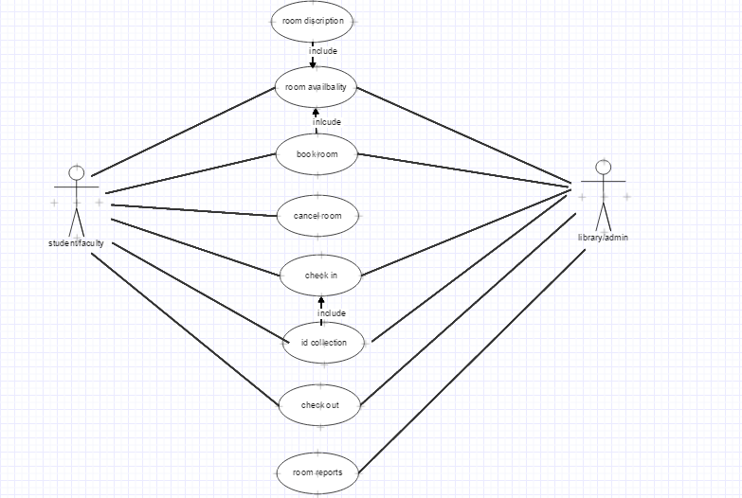

<<SYSTEM>>

# SEQUENCE

## ROOM AVAILABILITY

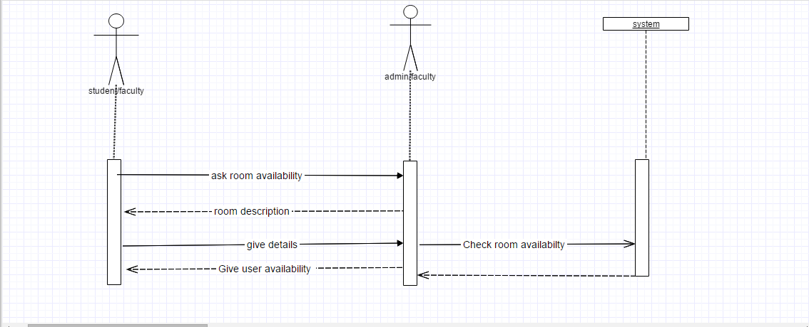

## BOOK A ROOM

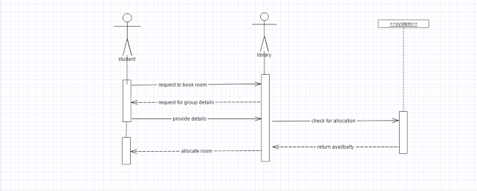

## REPORTS:

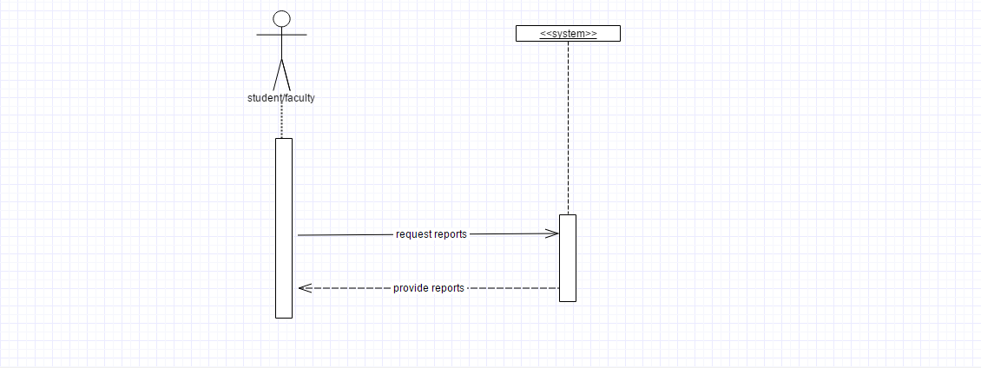

## CHECK IN AND OUT

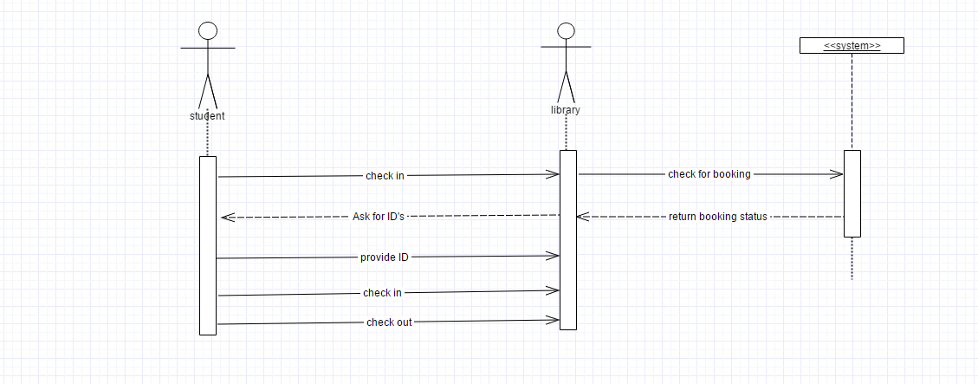

# CLASS DIAGRAM

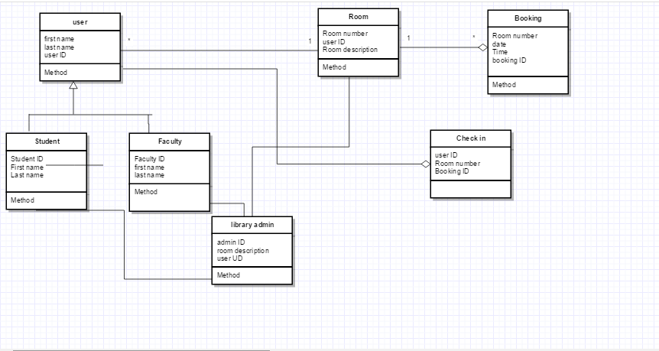

# ER DIAGRM

Time refers to hours of booking the room

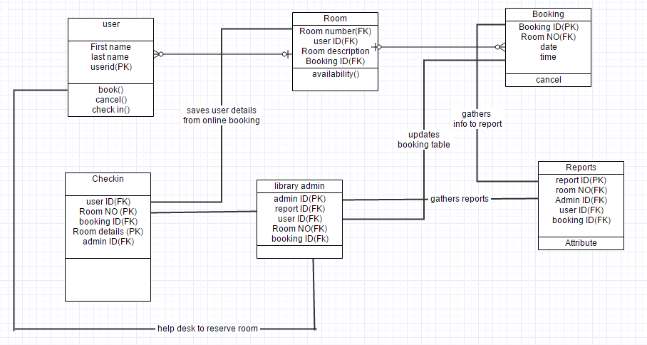

# SQL QUERIES:

* SELECT BookingID and time FROM booking WHERE RoomNO; This statement will help administrator to select the booking Ids and time for how much a room is used. This will give the insights on the
* SELECT RoomNO FROM Reports WHERE User_id IS value; This statement will help administrator to search the users RoomNo from reports. This helps to know which user books the room.
* SELECT User_id WHERE Booking ID; This helps us to understand all the User_ID’s associated with the booking ID.